**ART FOUNDATIONS /CONTEMPORARY ARTIST RESEARCH** (Presentation Day)

During/after presentations, **write a few notes** about each artist under his/her name (type of art, materials, theme, etc.) Then match the artists with their work. Example: **Pablo Picasso** – *painter, expressive, abstract, bright/bold colors. Painted portraits, cubist instruments*

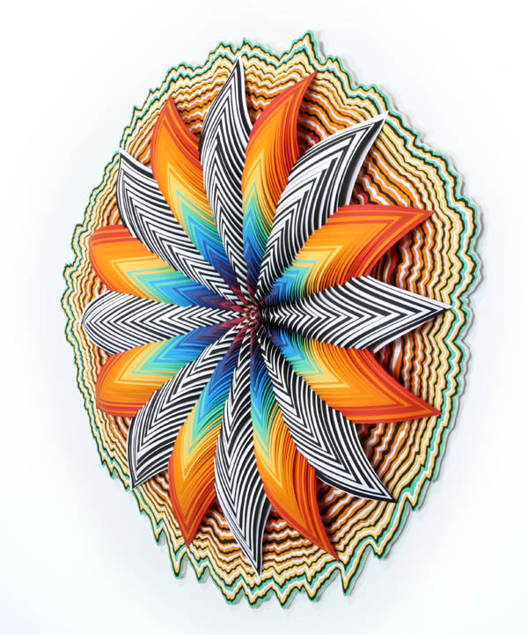

**Ferry Staverman**

**Jen Stark**

**Leonardo Drew**

**Deborah Butterfield**

**Maya Lin**

**Jean Claude and Christo**

**Kehinde Wiley**

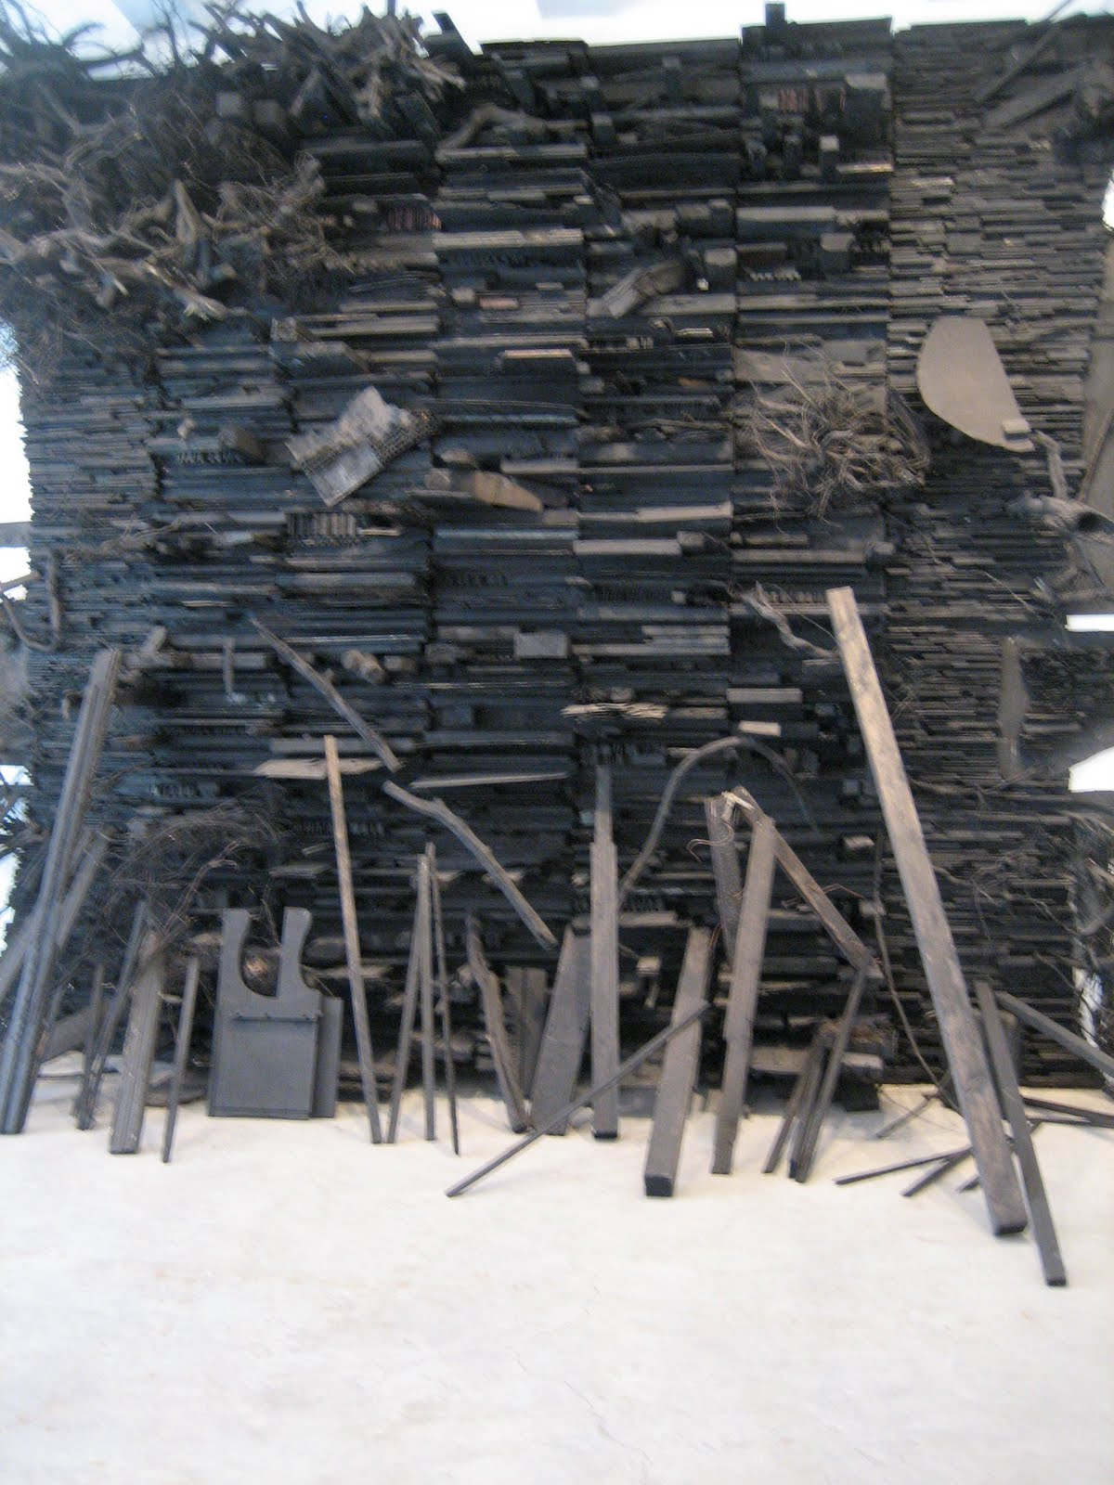

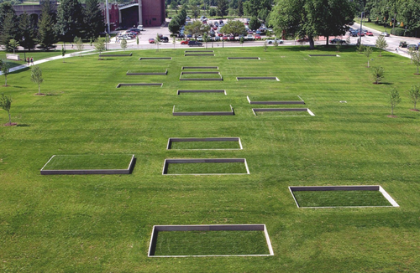

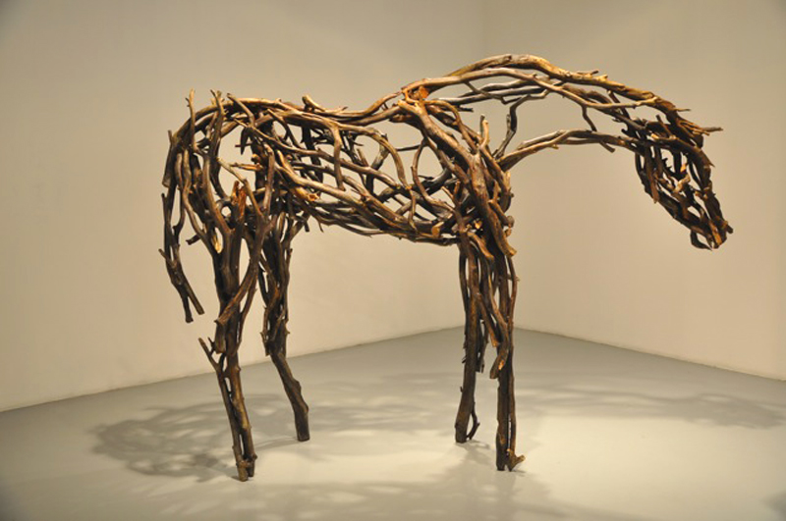

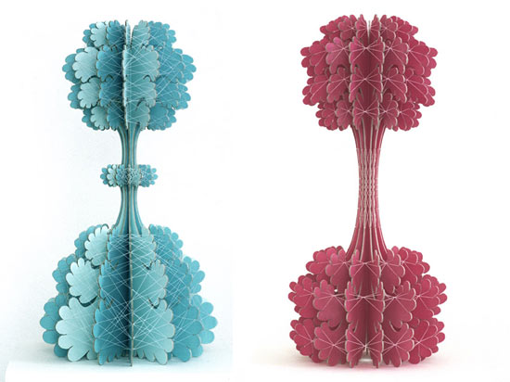

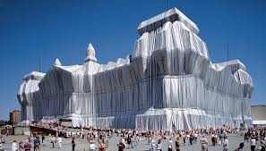

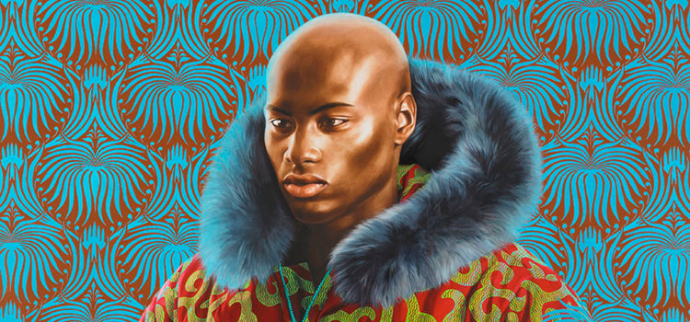

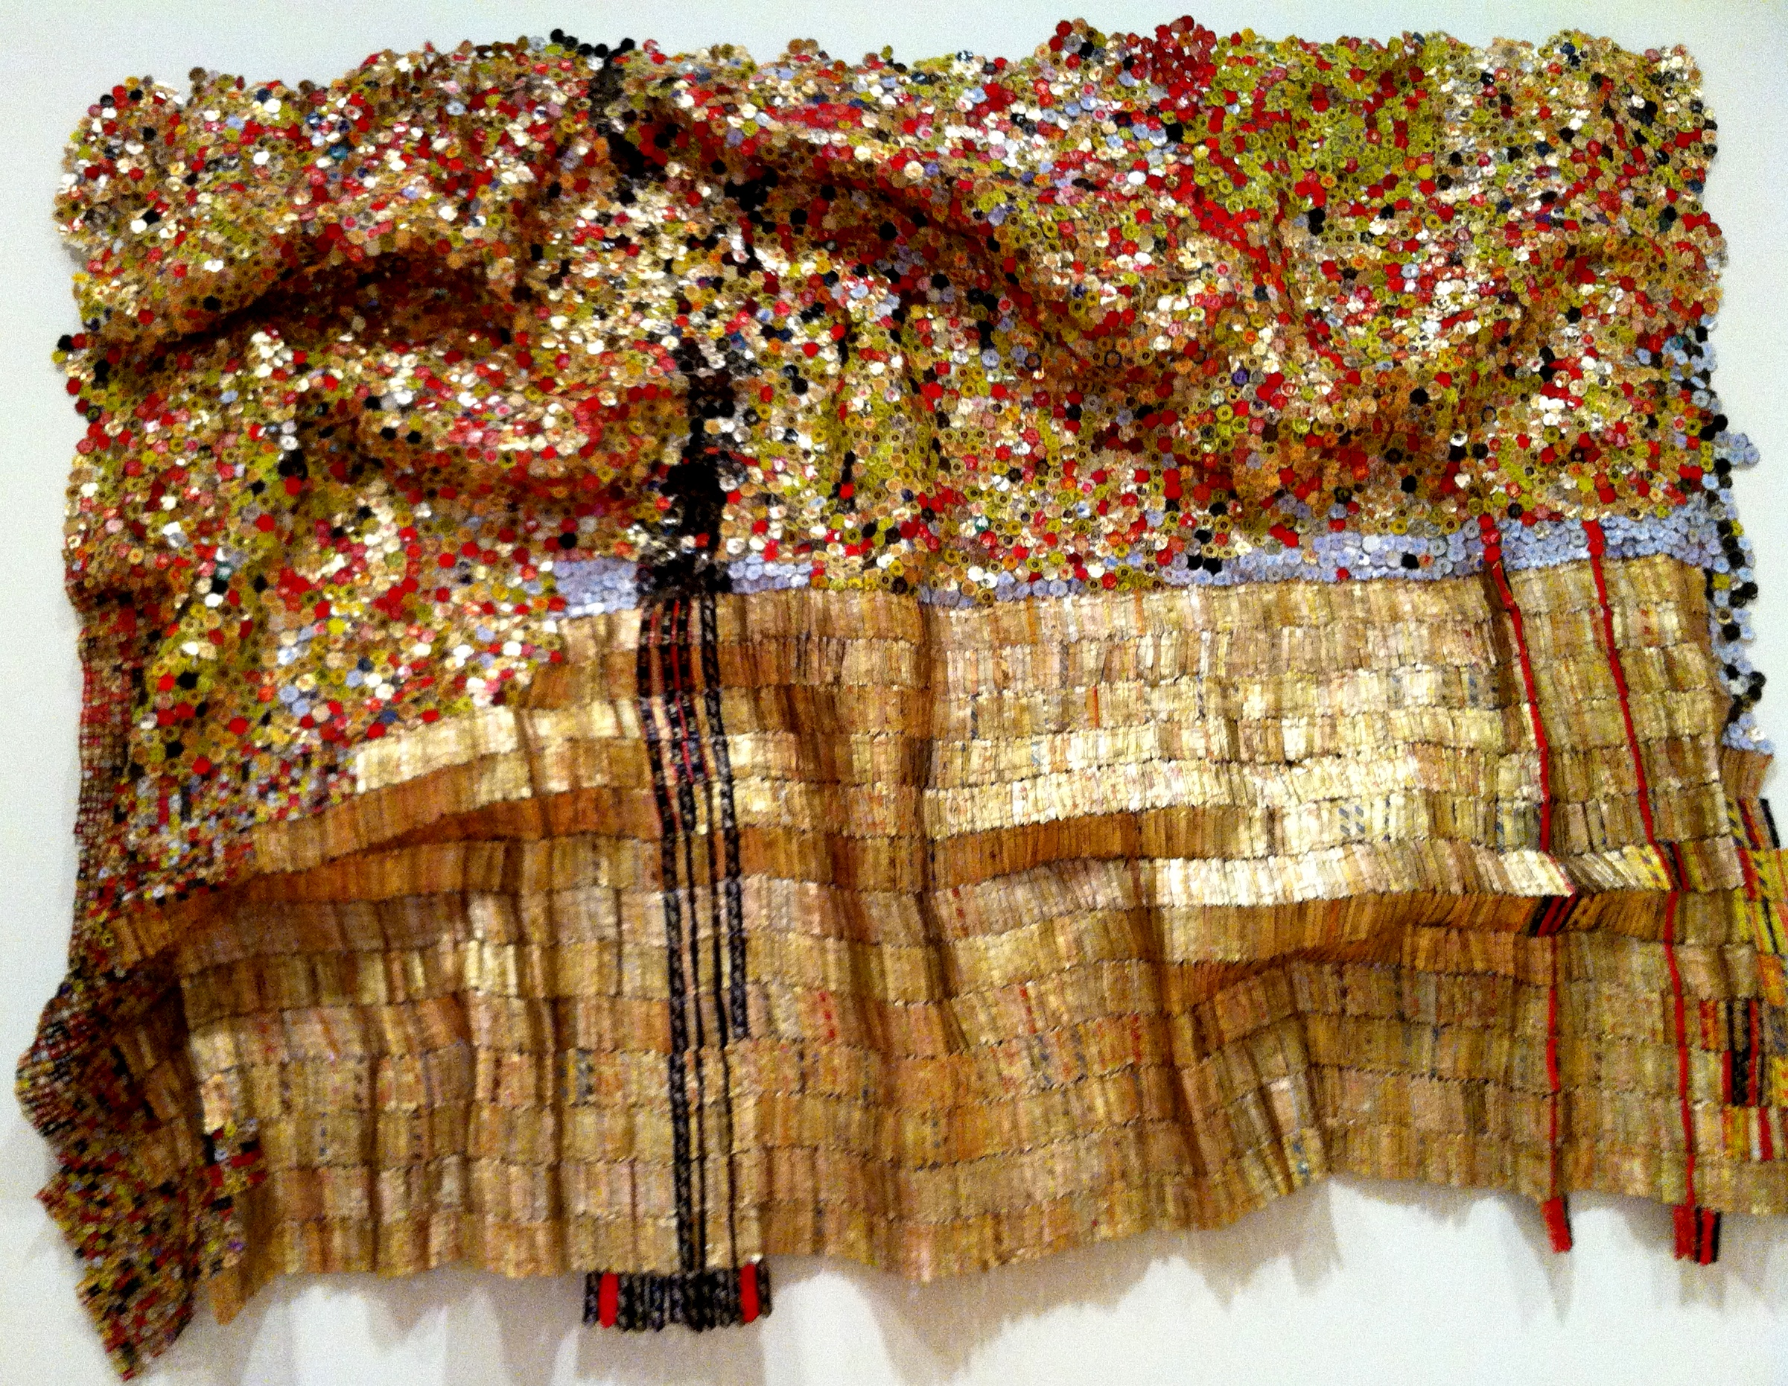

**El Anatsui**

**Louise Nevelson**

**Mary Ellen Clark**

**Cindy Sherman**

**Betty Woodman**

**Lotta Jansdotter**

**Gail Erwin**

**Jean Michel Basquiat**

**JoAnne Carson**

